Prague, 03. January 2022

New RAILWAY CONNECTION PraHA-Smíchov – BerouN
(Beroun Tunnel)

INVITATION TO PARTICIPATE in the First Meet the Buyer
Subject:

Geotechnical investigation
Správa železnic, státní organizace (railroads administrator in the Czech Republic), ID no.: 709 94 234, with its registered office at Praha 1 - Nové Město, Dlážděná 1003/7,110 00 (the “Client”) would like to invite you to participate in a "Meet the Buyer" meeting of the Client with potential contractors (the “Contractors”) for the purpose of familiarising the Contractors with the plans of the Client in the field of geotechnical investigation for the New railway connection Praha-Smíchov – Beroun (the “Area”).
The Client plans to launch a tender procedure for a larger number of public tenders in the defined Area in the upcoming period, and therefore, in order to streamline the competition for these public contracts and to ensure market capacity, the Client has decided to organise a joint meeting with Contractors in the form of Meet the Buyer.
1. DEFINITION OF THE PURPOSE AND SUBJECT OF MEET THE BUYER
The purpose of Meet the Buyer is to acquaint Contractors with the planned public contracts of the Client in the Area.
The basic introduction to the project is presented in Annex 1. The concept of geotechnical investigation is presented in Annex 2.
2. PARTICIPATION IN MEET THE BUYER
Meet the Buyer is opened to a wide range of relevant participants. Participation is open to any Contractor who demonstrates recent history (within the last 10 years) in the execution of core boreholes in hard rock environment (diamond core drilling) with depth of a single borehole more than 50 m and with number of such boreholes greater than 10 pcs of boreholes. The contract which the Contractor demonstrates experience with may be currently in progress. The Client shall take into account both local and overseas relevant experience corresponding to the above requirements.
In order to demonstrate the experience, those interested in participating in Meet the Buyer shall fill in the Registration Form attached as Annex 3 to this invitation and send it by e-mail no later than 24th January 2022 23:00 to the e-mail address domanicka@spravazelenic.cz. If the interested party sends the Registration Form after the set deadline, the possibilities of their participation in Meet the Buyer will be assessed according to the current operating conditions, in which case the Client cannot guarantee a positive processing of the application.
3. EXPECTED COURSE OF MEET THE BUYER
Meet the Buyer will be held as a video conference call, which will take the form of a remote meeting between representatives of the Client and representatives of the Contractors (the “Videoconference”). Contractors who submit the completed Registration Form to the Client within the set deadline will be allowed to participate in the Videoconference and, where appropriate, will be given access to the documents to be presented during the Videoconference.
Each Contractor participating in the Videoconference will be sent login details and instructions for joining the Videoconference. In particular, the Videoconference will record the area with the representatives of the Contracting Authorities who will be speaking and presenting relevant documents at a given moment. If the Contractors participating in the Videoconference have any questions, the Client points out that their image may also be transmitted at that moment.
Each Contractor will only be able to join the Videoconference via a maximum of two devices and it will not be relevant how many people are physically present at each device. If more than two devices log in for one Contractor, they will be removed from the Videoconference.
The Client will take all reasonable organisational and financial measures to ensure that the Videoconference enables a way of communicating with Contractors as if the Client had arranged a personal meeting with the Contractors. On the other hand, the Client does not guarantee the functionality or smooth running of the Videoconference. In order to eliminate transmission failure, the Client recommends connecting to the Videoconference via a stable high-speed internet connection.
During the joint meeting within the Videoconference, the Client will first present their intention of the public contract in general terms and the initial technical solution of the project in the form of a presentation. A guided discussion on these topics will follow.
A record of the course of the Videoconference will be made in the form of meeting minutes and at the same time an audio or video recording. By participating in the Videoconference, the Contractor's representative agrees to the processing of personal data and to the making of a written and audio or video recording for internal purposes of Správa železnic.
4. TIME AND PLACE OF MEET THE BUYER
The Videoconference is scheduled for:
- 26/01/2022 at 9:30 a.m. in Czech
- 27/01/2022 at 9:30 a.m. in English
The Videoconference call will take place via the Microsoft Teams application. Each registered Contractor can participate in both Videoconferences. Translation will not be provided.
The estimated duration of the Consultation is from 2 to 3 hours.
5. COMMUNICATION BETWEEN THE CLIENT AND THE CONTRACTOR
All documents related to Meet the Buyer will be prepared in both Czech and English. Communication between Contractors and the Client will be conducted exclusively in Czech or English.
6. CONCLUSION
Please send any questions regarding Meet the Buyer exclusively by e-mail to domanicka@spravazeleznic.cz.
Thank you for your cooperation and we look forward to your participation in Meet the Buyer.
ANNEX 1
PROJECT INTRODUCTION
The construction of the new line Praha-Smíchov – Beroun is a priority infrastructure project of the Client and one of the largest transport projects in the Czech Republic. Its aim is to build a completely new double-track section on the 3rd transit corridor, which will directly connect the stations Praha-Smíchov and Beroun and thus relieve the existing line along the Berounka river for suburban railway and make passenger and freight transport from the direction of Beroun, Plzeň, Nuremberg/Munich faster and more attractive.
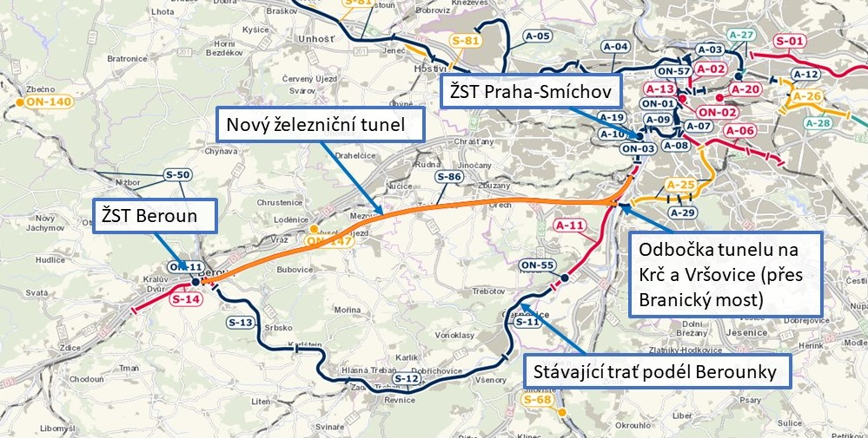
As part of the Project, a twin tunnel of length of approximately 25 km will be built at a depth of up to 130 m below the surface. Two single-track tunnel tubes will be built. The majority of the tunnelling will be carried out by TBM tunnelling machines. Lesser part and crossovers will be built by NATM. As there is insufficient space in the portal areas for adequate site equipment, the tunnelling and muck management will be carried out from shafts located along the tunnel route.
The construction site plan, longitudinal profile and longitudinal geology profile are provided on the following pages.
The project is currently in the design stage of preparation of the documentation for the planning permission (“DUR”), which will be completed in 2023. Between 2024 and 2026, we plan to prepare documentation for construction permit ("DSP") with the implementation of the project between 2027 and 2036. If the contractual conditions would change to the design & build type, we expect to commence the construction in approximately 2025. The estimated cost of the project is CZK 38 billion.
More information is available on the project website: https://www.spravazeleznic.cz/praha-beroun

ANNEX 2
CONCEPT OF GEOTECHNICAL INVESTIGATION
The geotechnical investigation designs are prepared by the designer of the DUR documentation (the Designer). Subsequently, the Client will issue a public tender for the execution of the geotechnical investigation and preparation of the geotechnical factual reports (the Contractor). The Designer will overlook the survey execution and prepare a geotechnical interpretative report based on the geotechnical factual reports.
The Client anticipates the following phasing of the geotechnical investigation
 | Tender start | Execution of geotechnical investigation | Scope of the Investigation
Phase 1
1A Shaft Survey | 02/2022 | 2022/2023 | 21 core boreholes, total of 1,575 m (approx. 200 m of soil, the rest is diamond drilling in the rock of HW and NW dia. Tests in boreholes, downhole geophysics, dilatometer testing, installation of piezometers, etc.). 9 boreholes longer than 100 m, maximum borehole length 160 m. 8 wells with total length of 590 m of non-core drilling, maximum depth of non-core drilling and casing of one borehole 150 m. Drilling in limestone and shale. Pumping tests. Electrical and seismic geophysical profiles. Estimated cost CZK 26 million including laboratory tests.
1B Survey of Gantries and Surface Items | 04/2022 | 2022/2023 | 4 horizontal boreholes 50 m long and 60 vertical boreholes 10 – 40 m long, a total of 1400 m. (approx. 400 m in the soil, the rest is diamond drilling in the rock of the NW dia). Tests in boreholes, downhole geophysics, dilatometers. Sampling + laboratories. Dynamic penetration 15x10 m. Seismic geophysical profiles 3x 500 m. Estimated cost CZK 11 million.
1C Borehole Raster Survey for Tunnel | 04/2022 | 2022/2023 | 68 core boreholes, a total estimate of 9,300 m. (approx. 700 m of soil, the rest is diamond drilling in the rock of HW and NW dia. Drilling in limestone and shale. Maximum borehole lengths 200 metres, average length of one borehole 135 metres. Borehole tests, downhole geophysics, dilatometer testing, installation of piezometers). 10 wells, 1,200 m of non-core drilling. Pumping tests. Estimated cost CZK 101 million including laboratory tests.
1D Geophysical Tunnel Survey | 04/2022 | 2022/2023 | ERT profiling with 500–750 m spacing along the entire length of the tunnel - approx. 24.5 km to identify the main faults and fault zones. Alternatively, it will be replaced by VES.  Estimated cost CZK 6 million.
Phase 2
2A Geophysical Supplementary Survey | 09/2023 | 2023/2024 | Reflective seismic measurements at the locations of the main faults and fault zones identified in Phase 1. Estimated for 1/3 of the line length. Estimated cost CZK 4 million.
Phase 3
3A Additional Drilling Survey | 08/2024 | 2024/2025 | Estimated cost CZK 34 million.

A large part of the survey will be carried out in the 2022/2023 winter season. We expect to use from 6 to 8 drilling rigs at a time. It is likely that surveys for the Erzgebirge Tunnel (25 km) and the Homole Motorway Tunnel (0.6 km) will be taking place at a similar time.
ANNEX 3
NEW RAILWAY CONNECTION PRAHA-SMÍCHOV – BEROUN
(BEROUN TUNNEL)
REGISTRATION FORM TO PARTICIPATE IN THE FIRST MEET THE BUYER
Subject:

Geotechnical INVESTIGATION
Client Identification:
Name: | Správa železnic, státní organizace
ID No.: | 709 94 234
Registered Office: | Praha 1, Nové Město, Dlážděná 1003/7, 110 00

Identification of an Interested Party to Participate in Meet the Buyer:
Name:
ID No.:
Registered Office:
Contractor's contact person for Meet the Buyer purposes: | Name:  Title:  E-mail:  Phone:
Persons who will participate in the Videoconference: | Name:  Title / Relationship to Contractor:  E-mail:  Name:  Title / Relationship to Contractor:  E-mail:

Qualification for Participation in the Consultation:
Recent history (within last ten years) in the execution of core boreholes in hard rock environment (diamond core drilling) with a depth of single borehole more than 50 m and with total number of such boreholes greater than 10 pcs of boreholes.
Reference Contract 1:
Reference Contract 2:

By signing, the party interested to participate in Meet the Buyer gives explicit consent to the processing of personal data and the recording of the meeting.

Place ____________, dated
______________________
Name:
Title:

